**EC-2 Hands-on**

**Creating the EC2 instance**

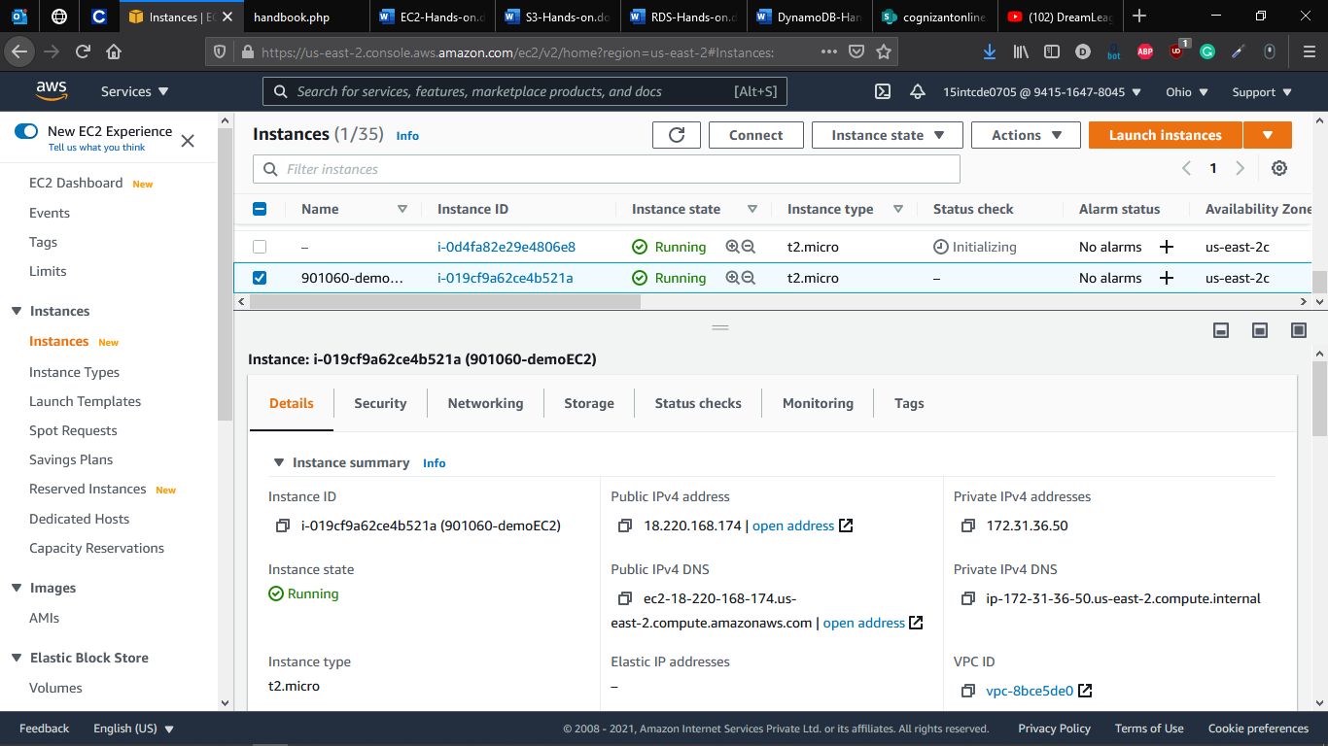

**Connecting Session to EC2 via SSH**

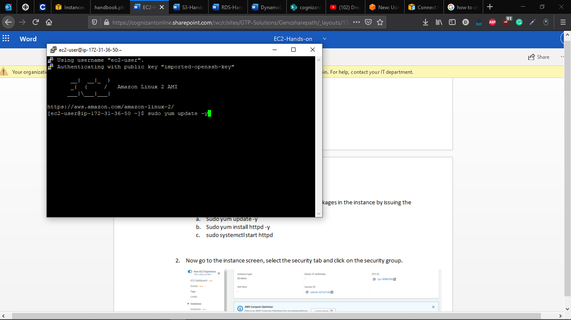

**Installing Apache Server to EC2 Instance created**

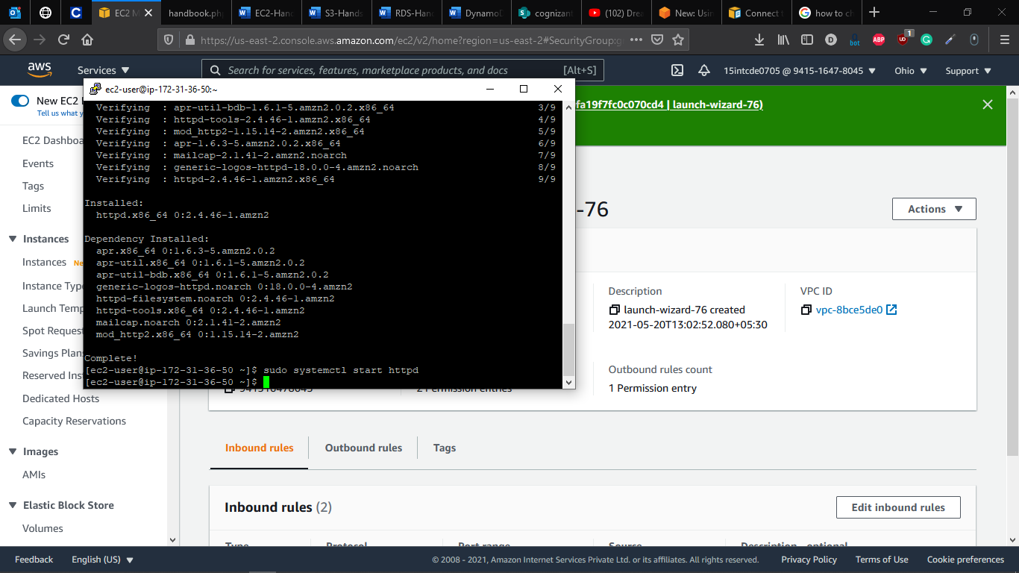

**Adding Inbound Rules to allow HTTP Connection to Apache Server**

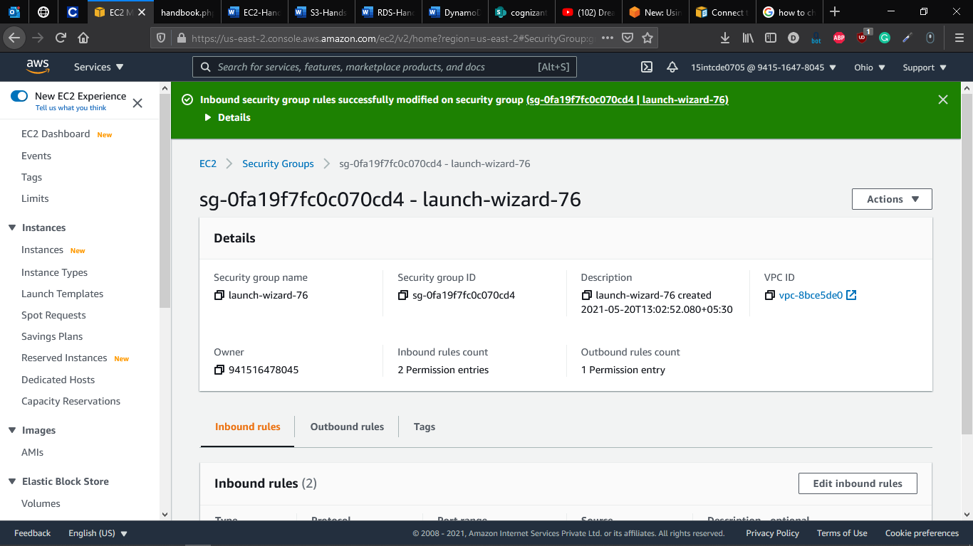

**Running Apache WebServer**

